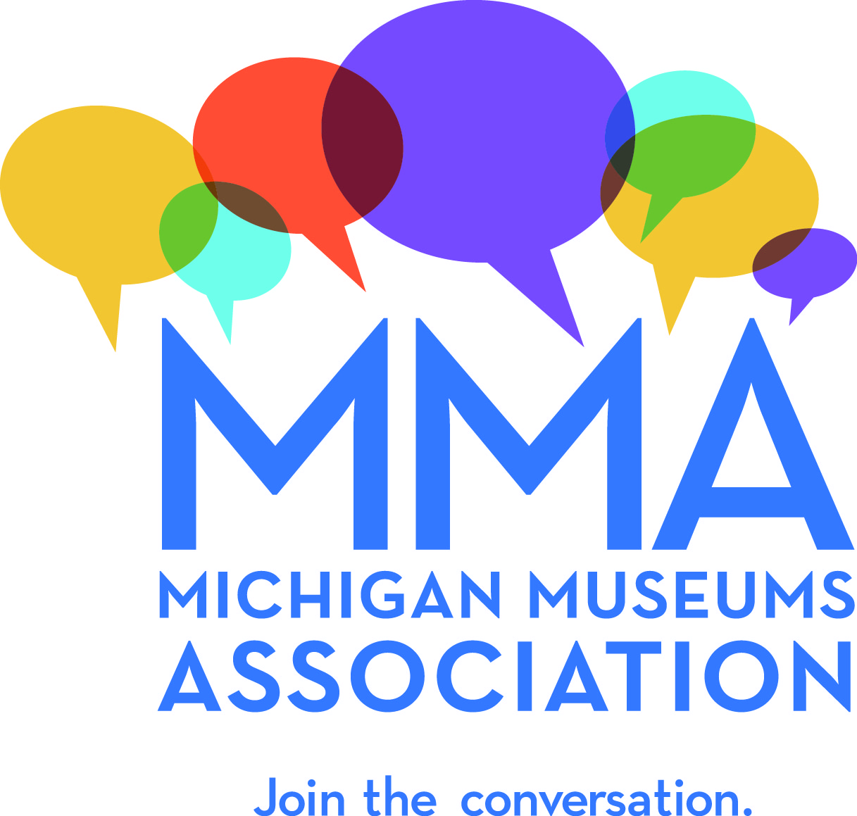

Conference Tours

The 2018 Michigan Museums Association’s Conference will take place in Dearborn, October 28, 29, and 30. The afternoon of Monday, October 29th, has been reserved for tours of local museums and cultural institutions in the Dearborn area.
The Michigan Museums Association invites organizations to propose focused tours of their facilities for MMA members. Engaging and “one of a kind” opportunities are encouraged. Applicants are encouraged to propose tours of museums, galleries, archives, special collections libraries, laboratories, storage facilities as well as tours of the Dearborn area—architecture tours, cemetery and grave marker tours, scavenger hunts, etc. We encourage you to create experiences for our visitors they would not likely be able
to find on their own.

Buses will depart from the Dearborn Inn and
participants will be dropped off at the tour sites.

Proposals can be submitted online or by
completing the form below and emailing
it to juliabtoro@gmail.com or mailing it
to PO Box 5246, Cheboygan, MI 49721.

Please complete forms no later than April 15.

MMA Conference Tour Proposal

Proposed Location:

Tour Description:
(Please provide several sentences describing the tour or experience - this information will be used in conference materials)

Duration of Tour:
(conference tours will take place between 3:00 and 5:30 on Monday, October 29 - the expected duration of your tour will help us plan the bus schedule)

Mobility Requirements:
(MMA conference participants have a variety of mobility levels - please list any specific barrier to access that tour participants might encounter for example stairs, extensive walking, confined spaces)

Other details/special instructions:

Minimum number:
(fewest number of people you would need signed up to justify holding this tour/experience)

Maximum number:
(how many participants can you accommodate?)

Contact Person/Tour Organizer:

Phone:

Email:

Tour Leader (if different from your organizer):

Phone for Tour Leader:

Email for Tour Leader:

Proposals can be submitted online or by completing the form below and emailing it to juliabtoro@gmail.com or mailing it to PO Box 5246, Cheboygan, MI 49721.

Please complete forms no later than April 15.

