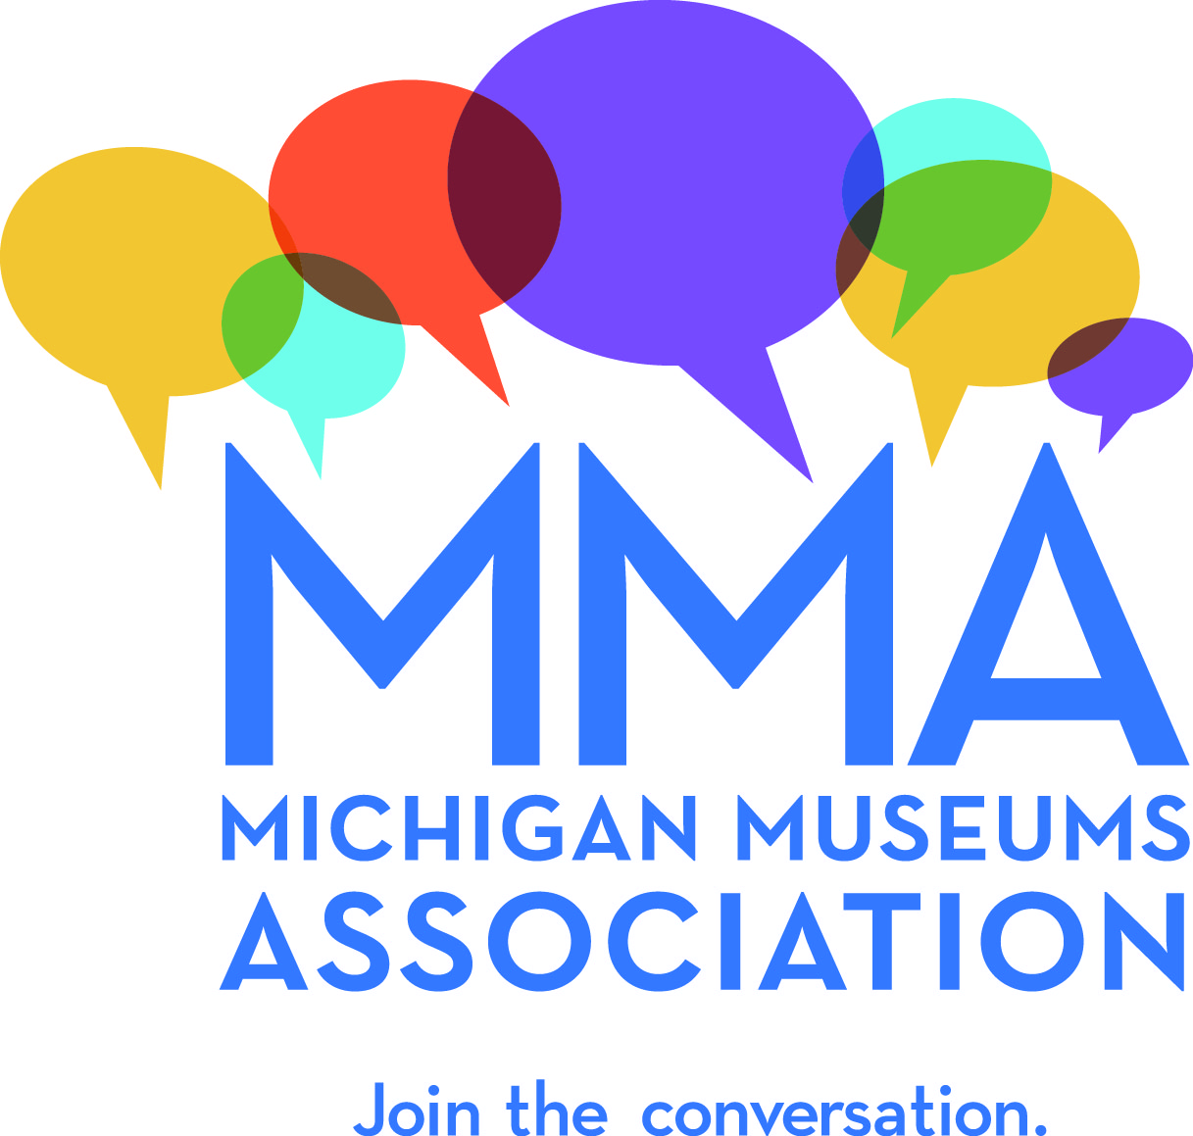
2017 MMA Conference Tours

The 2017 Michigan Museums Association(MMA)’s Conference, Sharing Our Stories: The Role of Michigan Museums, will be held at the Radisson Hotel Lansing at the Capitol, October 17-19. We are excited to gather the Michigan museums community in Greater Lansing and plan to highlight unique aspects of the area by offering tours and special experiences on the afternoon of October 18, from 3-5 pm.
The Michigan Museums Association invites cultural organizations to host focused tours for MMA members and conference participants. Engaging, “one of a kind” opportunities are welcomed and encouraged, since the MMA audience understands and appreciates the efforts required to develop such experiences. Ideas include:
- Behind-the-scenes tours of museums, galleries, archives, special collections libraries, laboratories, and storage facilities.
- Walking tours that uncover the capital city’s hidden treasures, including architecture, cemeteries, markers, and historical hotspots.
Hosts are expected to waive admission fees and other expenses, but will be considered conference sponsors and acknowledged in conference materials.

All tours will depart from the Radisson Hotel Lansing at the Capitol, October 18 at 3:00 pm, to be completed by 5:00 pm. Preference will be given to experiences within walking distance from the hotel, or when transportation is provided by the host. MMA may be able to provide transportation to offsite locations.

If you are interested in offering a tour or experience, please complete the attached form and email it to lcbrisson@michiganmusuems.org no later than March 31.

MMA Conference Tour Proposal

Tours will take place between 3:00 and 5:00 on Wednesday, October 18th. If within walking distance or providing transportation, tour hosts will be responsible for meeting participants at Radisson Hotel Lansing at the Capitol by 3:00 and escorting them to the tour location.

Tour Location:

Tour Description:
(No more than 100 words that will be used to promote your experience)

Duration of Tour:
(including travel time from Radisson Hotel Lansing at the Capitol)

Mobility Requirements:
(need to be able to use stairs, requires prolonged walking, needs to be comfortable in confined spaces, etc.)

Other details/special instructions:

Minimum # of participants needed to hold the tour:

Maximum # of participants you can handle:

Contact Person/Tour Organizer:

Phone:

Email:

Please complete form and email it to lcbrisson@michiganmusuems.org no later than March 31.

